LINUX PROCESS
Command Line Arguments of a Process
- Write a C program that accepts multiple filenames as command line arguments and prints the size of each file.
PROGRAM:
/*
Program to display the size of files provided as command-line arguments
Author : MUTHUGANESH S
Date : 08/03/2026
Filename : filesize.c
*/

#include <stdio.h>

int main(int argc, char *argv[])
{
FILE *fp;
long size;
int i;

if(argc < 2)
{
printf("Usage: %s filename1 filename2 ...\n", argv[0]);
return 1;
}

for(i = 1; i < argc; i++)
{
fp = fopen(argv[i], "r");

if(fp == NULL)
{
printf("Cannot open file %s\n", argv[i]);
continue;
}

fseek(fp, 0, SEEK_END);
size = ftell(fp);

printf("File: %s Size: %ld bytes\n", argv[i], size);

fclose(fp);
}

return 0;
}
OUTPUT:
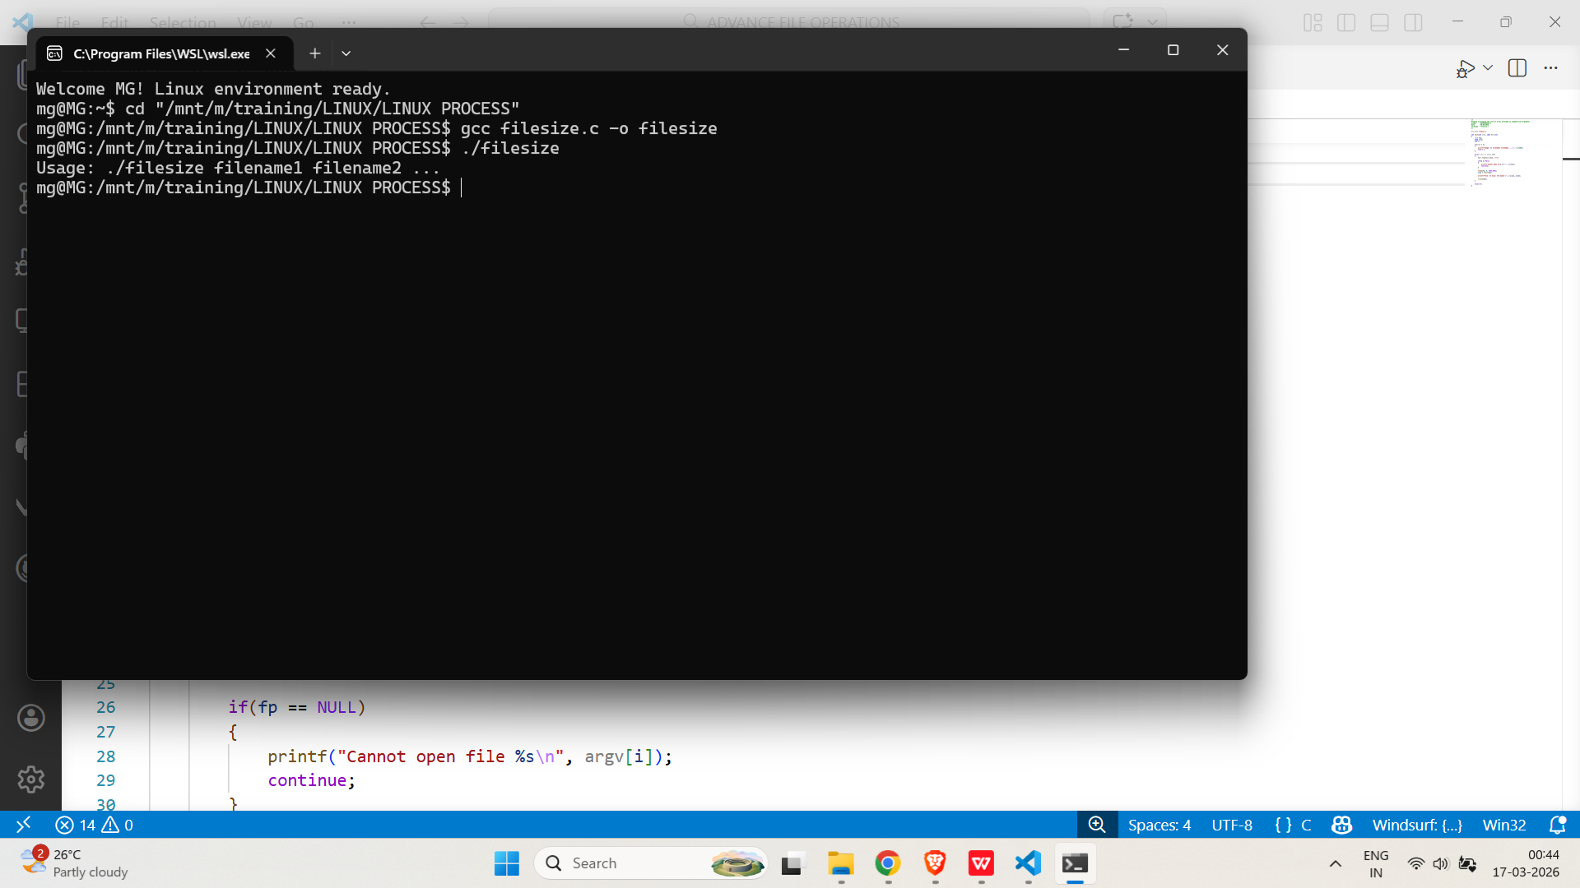
- Implement a program that parses command line arguments to perform different operations (e.g., add, subtract, multiply) on two integers.
PROGRAM:
/*
Program to perform basic arithmetic operations based on command-line arguments.
Author : MUTHUGANESH S
Date : 05/03/2026
Filename : cal.c
*/

//header files
#include <stdio.h>
#include <stdlib.h>
#include <string.h>

int main(int argc, char *argv[])
{
int a, b;

if(argc != 4)
{
printf("Usage: %s operation num1 num2\n", argv[0]);
return 1;
}

a = atoi(argv[2]);
b = atoi(argv[3]);

if(strcmp(argv[1], "add") == 0)
printf("Result = %d\n", a + b);
else if(strcmp(argv[1], "sub") == 0)
printf("Result = %d\n", a - b);
else if(strcmp(argv[1], "mul") == 0)
printf("Result = %d\n", a * b);
else
printf("Invalid operation\n");

return 0;
}
OUTPUT:
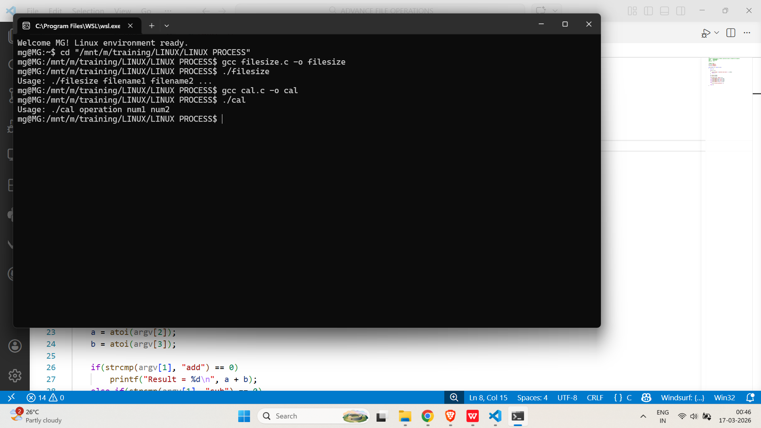
Environment of a Process
- Write a C program that prints all environment variables of the current process.
PROGRAM:
/*
Program to print environment variables
Author : MUTHUGANESH S
Date : 07/03/2026
Filename : env.c
*/

#include <stdio.h>

// Global variable that holds the environment variables
extern char **environ;

int main()
{
char **env = environ;

while(*env != NULL)
{
printf("%s\n", *env);
env++;
}

return 0;
}

OUTPUT:
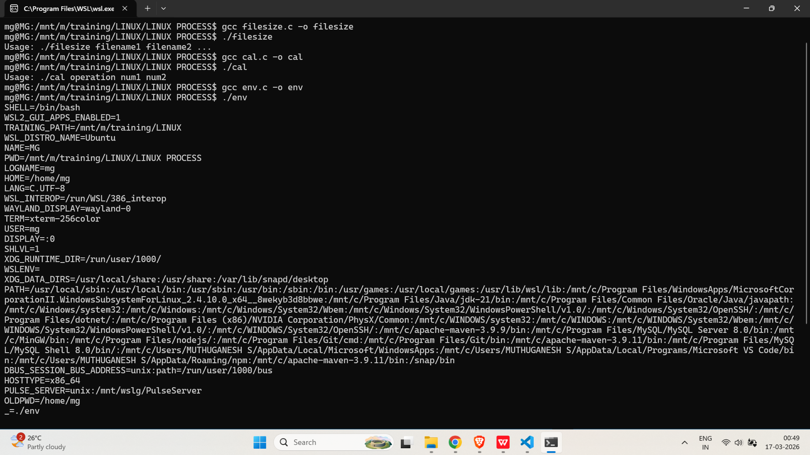
- Implement a program that sets a custom environment variable and then retrieves its value using getenv().
PROGRAM:
/*
Program to set and get environment variables in C.
Author : MUTHUGANESH S
Date : 07/03/2026
Filename : set.c
*/

//header files
#include <stdio.h>
#include <stdlib.h>

int main()
{
setenv("MY_VAR", "HelloEnvironment", 1);

char *value = getenv("MY_VAR");

if(value != NULL)
printf("MY_VAR = %s\n", value);
else
printf("Environment variable not found\n");

return 0;
}

OUTPUT:
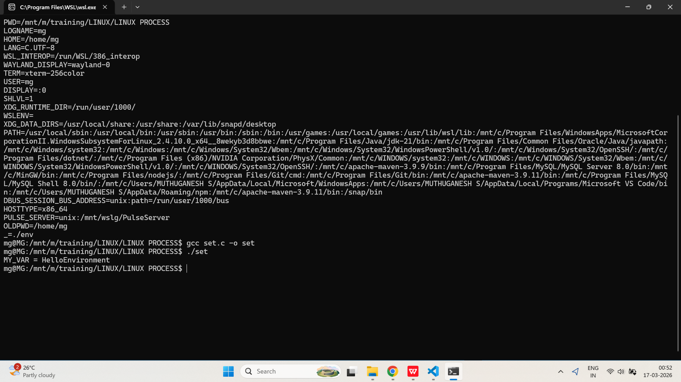
fork
- Write a C program that creates a child process using fork() and prints the process IDs of both parent and child.
PROGRAM:
/*
Program to implement fork()
Author : MUTHUGANESH S
Date : 08/03/2026
Filename : atomic.c
*/

// Include necessary header files
#include <stdio.h>
#include <unistd.h>

int main() {
// Create a child process using fork()
pid_t pid;

pid = fork();

if (pid < 0) {
printf("Fork failed\n");
return 1;
}
else if (pid == 0) {
// Child process
printf("Child Process:\n");
printf("PID: %d\n", getpid());
printf("Parent PID: %d\n", getppid());
}
else {
// Parent process
printf("Parent Process:\n");
printf("PID: %d\n", getpid());
printf("Child PID: %d\n", pid);
}

return 0;
}
OUTPUT:
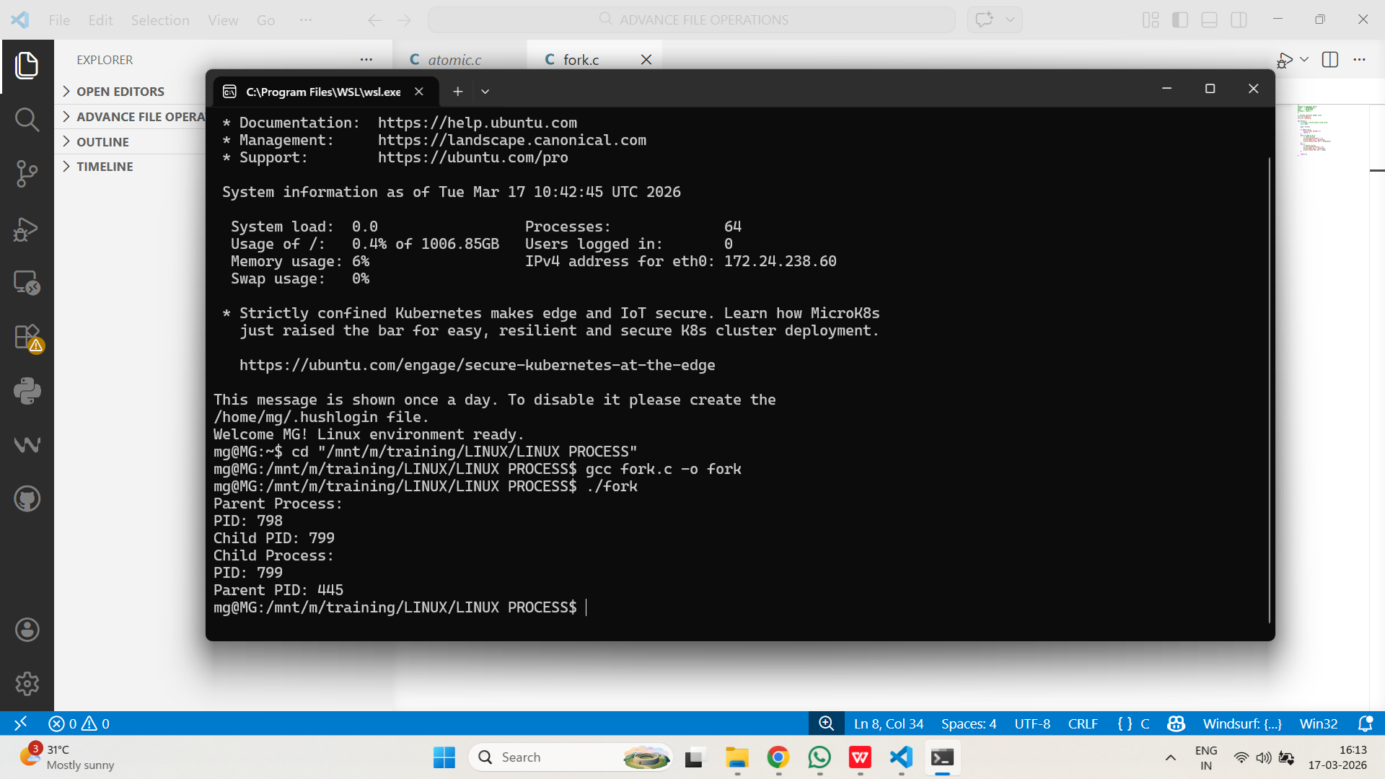

- Implement a program where the parent and child process each write to a shared file after fork(). Analyze the output.
PROGRAM:
/*
Program to implement shared log file
Author : MUTHUGANESH S
Date : 08/03/2026
Filename : shar.c
*/

// Include necessary header files
#include <stdio.h>
#include <unistd.h>
#include <fcntl.h>
#include <sys/types.h>

int main() {
int fd;
pid_t pid;

fd = open("shared.txt", O_WRONLY | O_CREAT | O_APPEND, 0644);

if (fd < 0) {
printf("File open error\n");
return 1;
}

pid = fork();

if (pid < 0) {
printf("Fork failed\n");
return 1;
}
else if (pid == 0) {
// Child process
write(fd, "Child writing\n", 14);
}
else {
// Parent process
write(fd, "Parent writing\n", 15);
}

close(fd);
return 0;
}
OUTPUT:
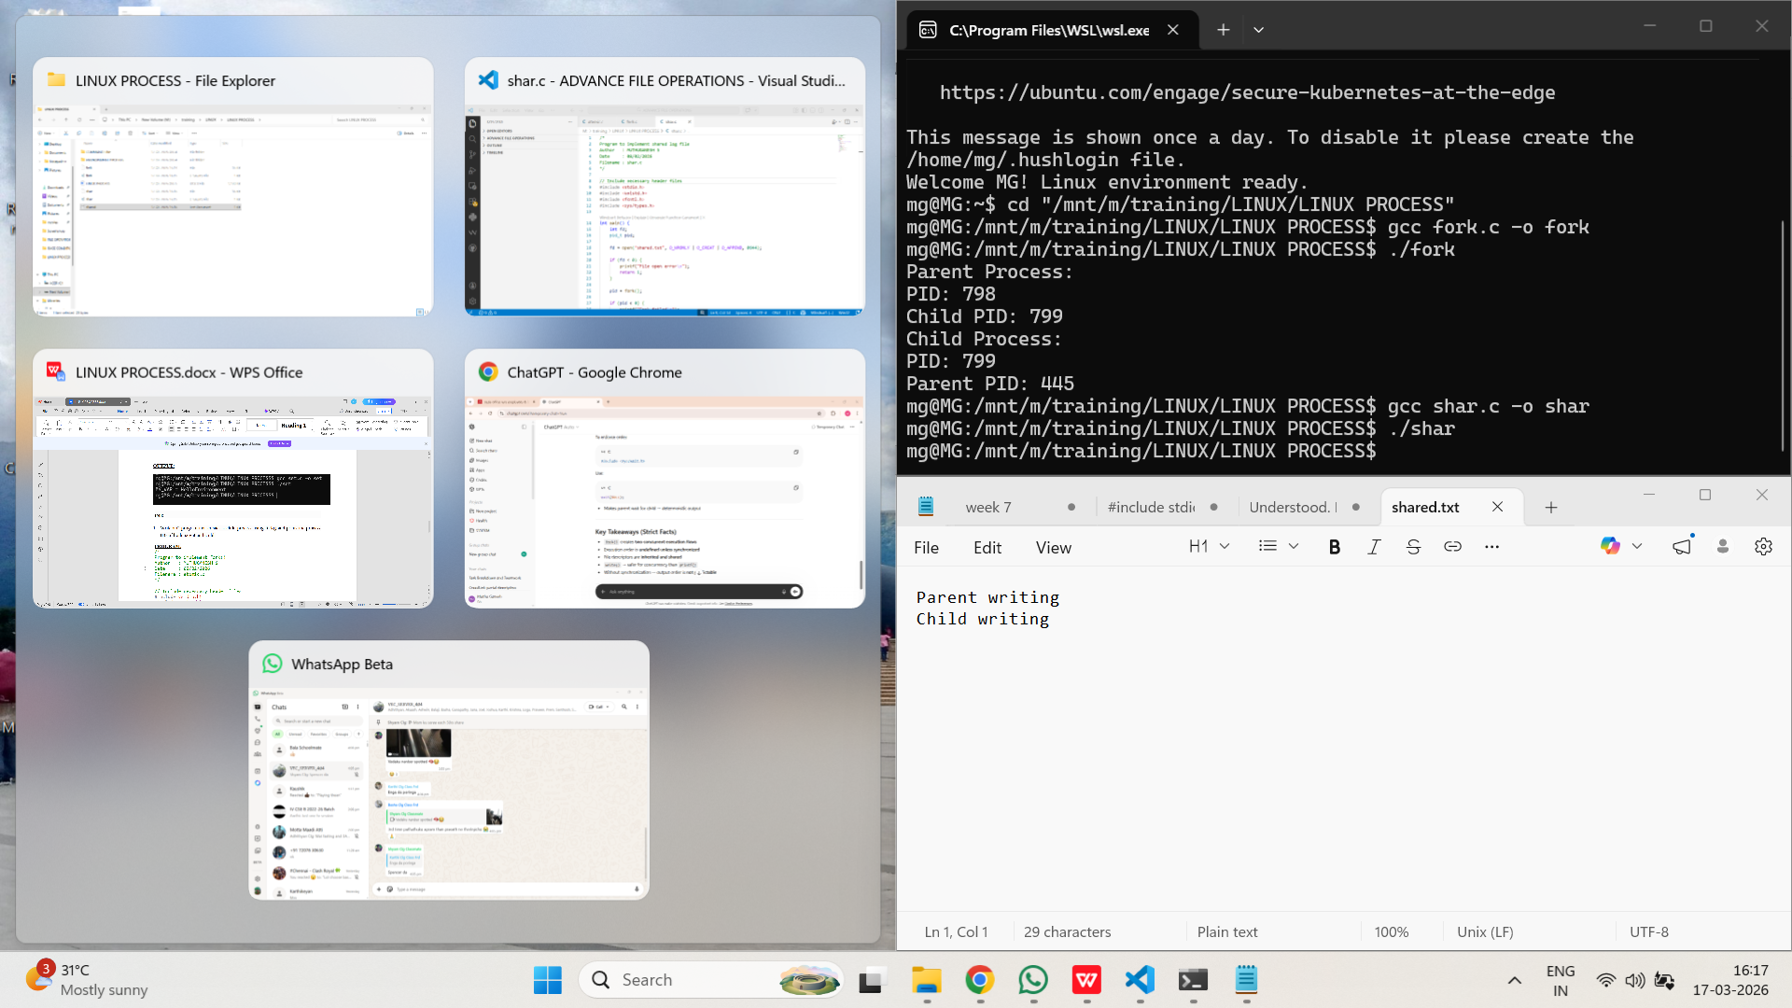

exec
- Write a C program that uses execvp() to replace the current process image with the ls command.
PROGRAM:
/*
Program to implement execvp()
Author : MUTHUGANESH S
Date : 08/03/2026
Filename : exe.c
*/

//Header files
#include <stdio.h>
#include <unistd.h>

int main() {
char *args[] = {"ls", "-l", NULL};

printf("Before execvp()\n");

// This line executes ONLY if execvp() succeeds
execvp("ls", args);

// This line executes ONLY if execvp fails
perror("execvp failed");
return 1;
}
OUTPUT:
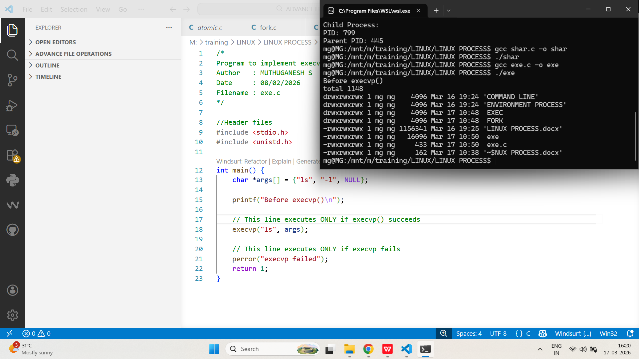

- Implement a program that forks a child and uses execlp() to run a different program, passing command line arguments.
PROGRAM:
/*
Program to implement fork() and execlp()
Author : MUTHUGANESH S
Date : 08/03/2026
Filename : fe.c
*/

// Include necessary header files
#include <stdio.h>
#include <unistd.h>
#include <sys/types.h>
#include <sys/wait.h>

int main() {
pid_t pid = fork();

if (pid < 0) {
perror("Fork failed");
return 1;
}
else if (pid == 0) {
// Child process
printf("Child: executing 'ls -a'\n");

execlp("ls", "ls", "-a", NULL);

// Executes only if execlp fails
perror("execlp failed");
return 1;
}
else {
// Parent process
wait(NULL);
printf("Parent: child finished execution\n");
}

return 0;
}

OUTPUT:
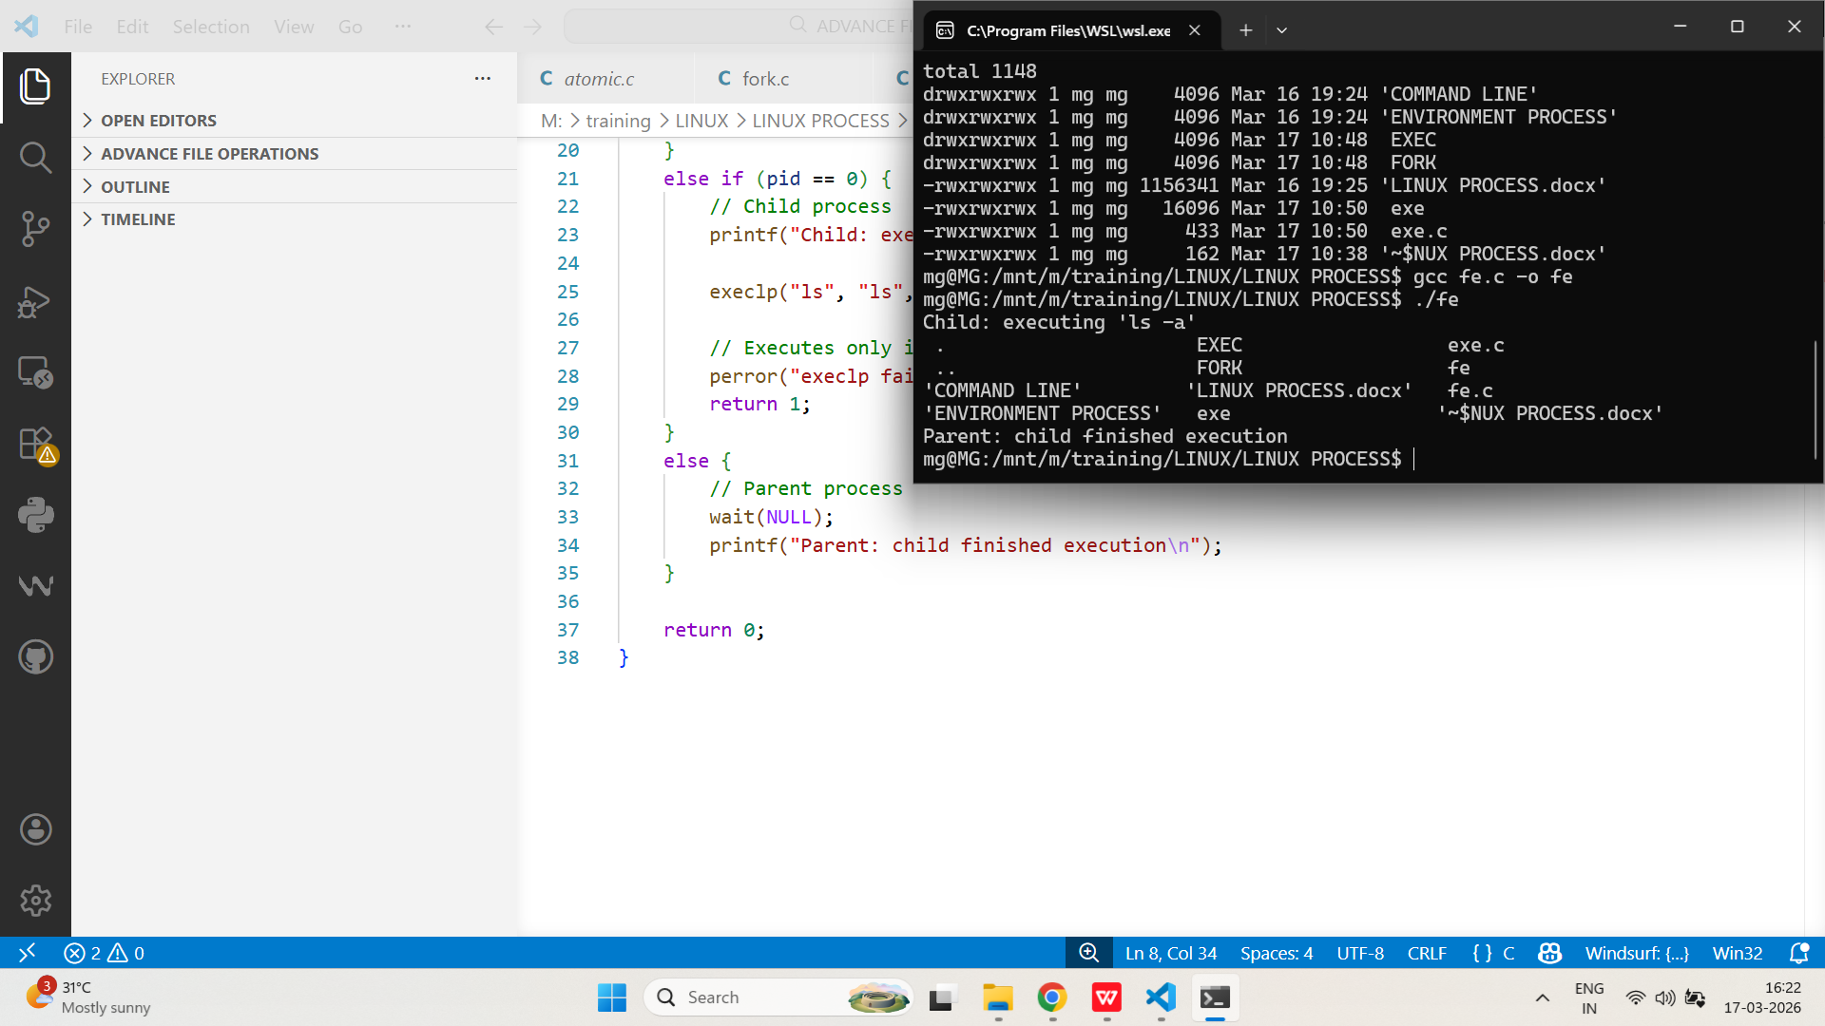
wait and waitpid
- Write a C program that creates multiple child processes and uses wait() to collect their exit statuses.
PROGRAM:
/*
Program to implement wait()
Author : MUTHUGANESH S
Date : 08/03/2026
Filename : wait.c
*/

// Include necessary header files
#include <stdio.h>
#include <unistd.h>
#include <sys/types.h>
#include <sys/wait.h>
#include <stdlib.h>

int main() {
int i;
pid_t pid;

for (i = 0; i < 3; i++) {
pid = fork();

if (pid == 0) {
// Child process
printf("Child %d: PID = %d\n", i, getpid());
exit(10 + i); // distinct exit codes
}
}

// Parent process
int status;
pid_t wpid;

while ((wpid = wait(&status)) > 0) {
if (WIFEXITED(status)) {
printf("Parent: Child with PID %d exited with status %d\n",
wpid, WEXITSTATUS(status));
}
}

return 0;
}
OUTPUT:
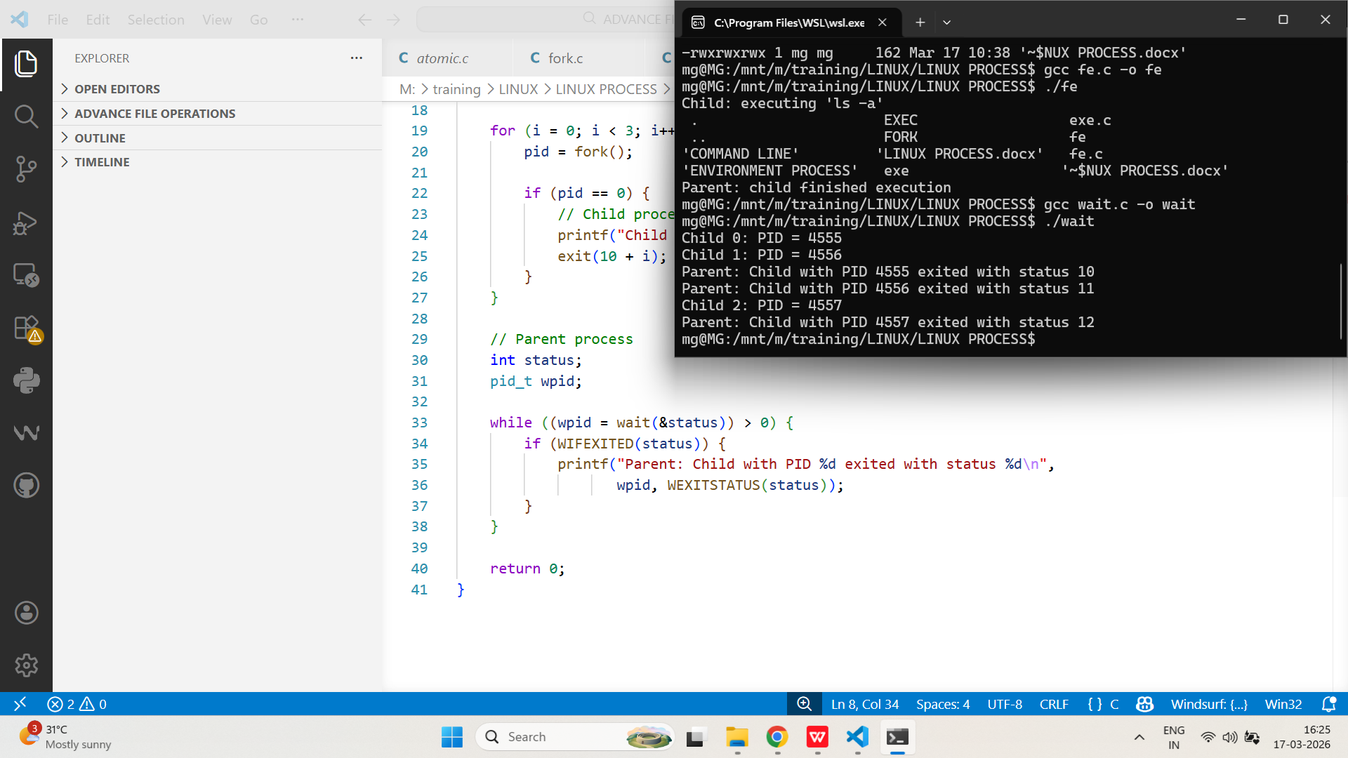

- Implement a program that uses waitpid() to wait for a specific child process to finish and prints its exit code.
PROGRAM:
/*
Program to implement waitpid()
Author : MUTHUGANESH S
Date : 08/03/2026
Filename : waitpid.c
*/

// Include necessary header files
#include <stdio.h>
#include <unistd.h>
#include <sys/types.h>
#include <sys/wait.h>
#include <stdlib.h>

int main() {
pid_t pid1, pid2;
int status;

pid1 = fork();

if (pid1 == 0) {
// First child
sleep(2);
printf("Child 1 done (PID=%d)\n", getpid());
exit(21);
}

pid2 = fork();

if (pid2 == 0) {
// Second child
sleep(1);
printf("Child 2 done (PID=%d)\n", getpid());
exit(42);
}

// Parent process
printf("Parent waiting specifically for child PID %d\n", pid1);

waitpid(pid1, &status, 0);

if (WIFEXITED(status)) {
printf("Parent: Child %d exited with status %d\n",
pid1, WEXITSTATUS(status));
}

// Clean up remaining child
wait(NULL);

return 0;
}
OUTPUT:
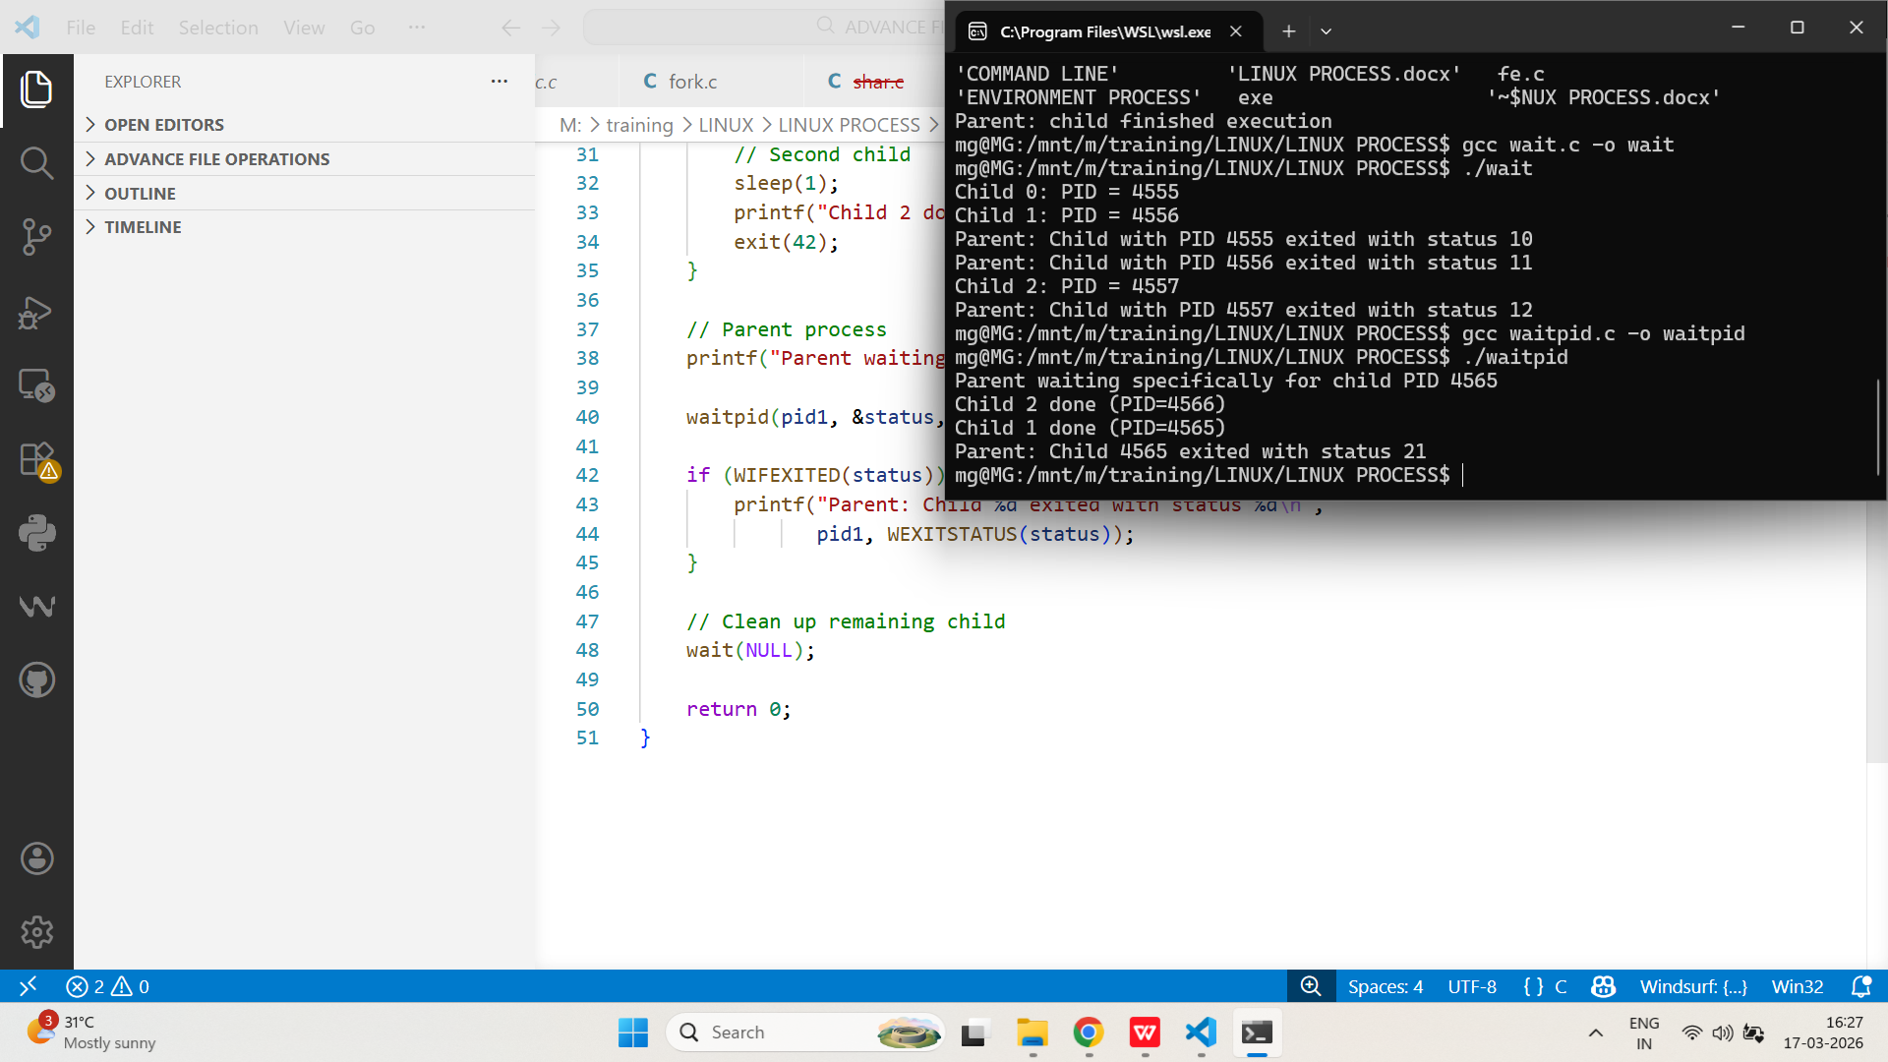

Orphan Process and Zombie Process
- Write a C program that creates an orphan process and demonstrates its adoption by the init process.
PROGRAM:
/*
Program to demonstrate orphan process creation in C.
Author : MUTHUGANESH S
Date : 09/03/2026
Filename : orp.c
*/

// Include necessary header files
#include <stdio.h>
#include <unistd.h>
#include <stdlib.h>

int main() {
pid_t pid = fork();

if (pid < 0) {
perror("fork failed");
return 1;
}
else if (pid == 0) {
// Child process
sleep(3); // ensure parent exits first

printf("Child: PID = %d\n", getpid());
printf("Child: New Parent PID = %d\n", getppid());

// Infinite loop to observe via ps
while (1) {
sleep(1);
}
}
else {
// Parent process
printf("Parent: PID = %d\n", getpid());
printf("Parent exiting...\n");
exit(0);
}

return 0;
}
OUTPUT:
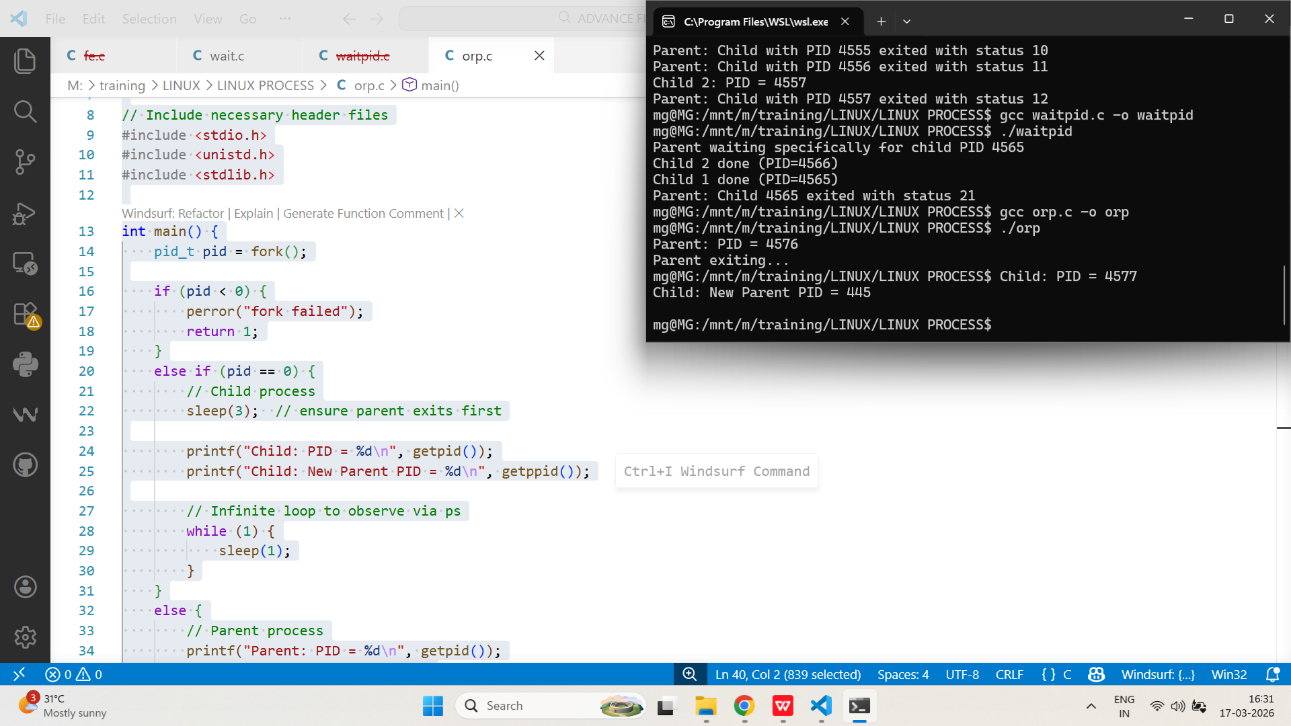
- Implement a program that creates a zombie process and shows how it appears in the process table until the parent calls wait().
PROGRAM:
/*
Program to demonstrate Zombie process creation in C.
Author : MUTHUGANESH S
Date : 09/03/2026
Filename : zom.c
*/

// Include necessary header files
#include <stdio.h>
#include <unistd.h>
#include <stdlib.h>

int main() {
pid_t pid = fork();

if (pid < 0) {
perror("fork failed");
return 1;
}
else if (pid == 0) {
// Child process
printf("Child exiting (PID=%d)\n", getpid());
exit(99);
}
else {
// Parent process
printf("Parent sleeping (PID=%d)\n", getpid());
sleep(10); // Delay wait()

// Uncomment to clean zombie:
// wait(NULL);

printf("Parent exiting\n");
}

return 0;
}
OUTPUT:
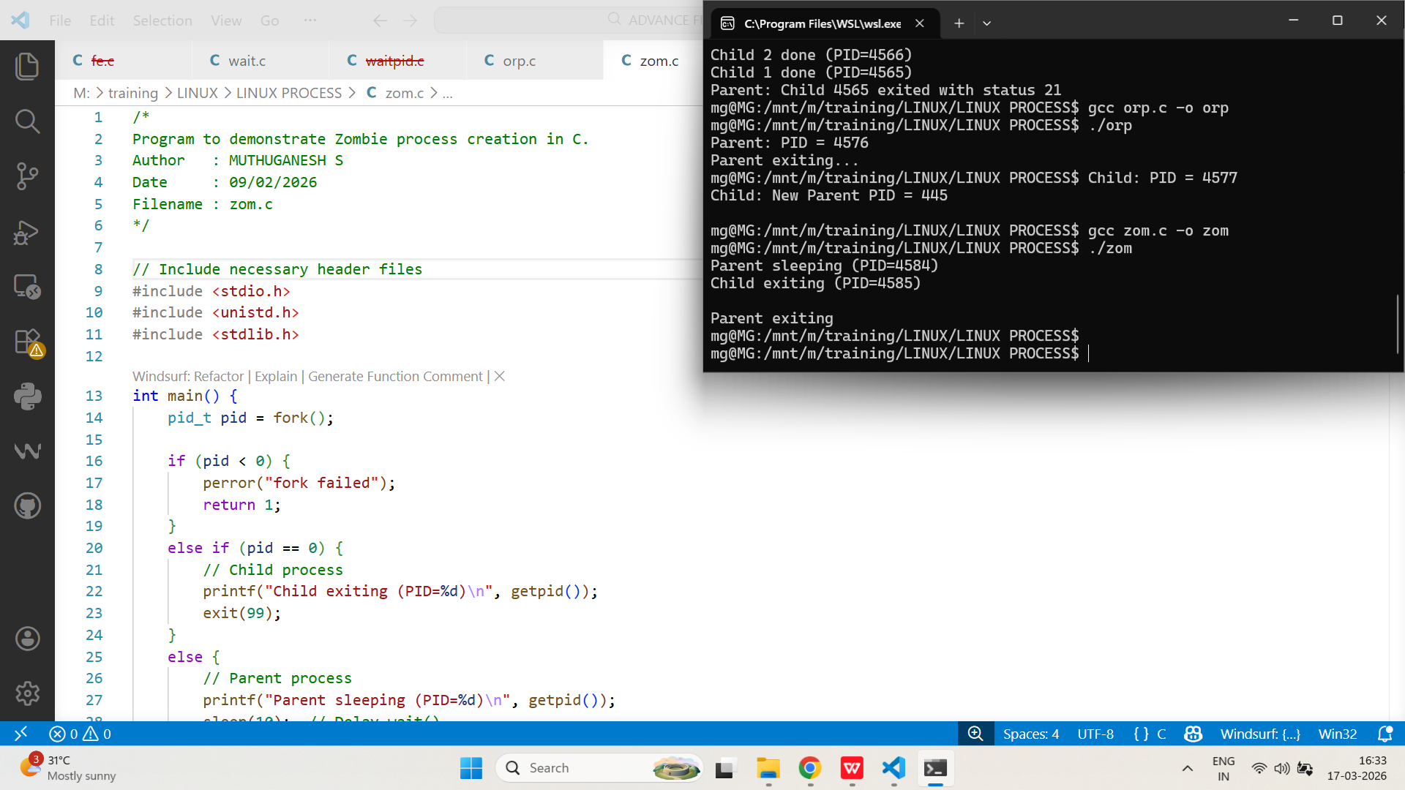
Signals
- Write a C program that handles SIGINT (Ctrl+C) and prints a message before exiting.
PROGRAM:
/*
Process Signal Handling Example in C
Author : MUTHUGANESH S
Date : 09/03/2026
Filename : sig.c
*/

// Include necessary header files
#include <stdio.h>
#include <stdlib.h>
#include <signal.h>
#include <unistd.h>

void handle_sigint(int sig) {
printf("\nCaught SIGINT (signal %d)\n", sig);
printf("Exiting gracefully...\n");
exit(0);
}

int main() {
signal(SIGINT, handle_sigint);

printf("Press Ctrl+C to trigger SIGINT...\n");

while (1) {
sleep(1);
}

return 0;
}
OUTPUT:
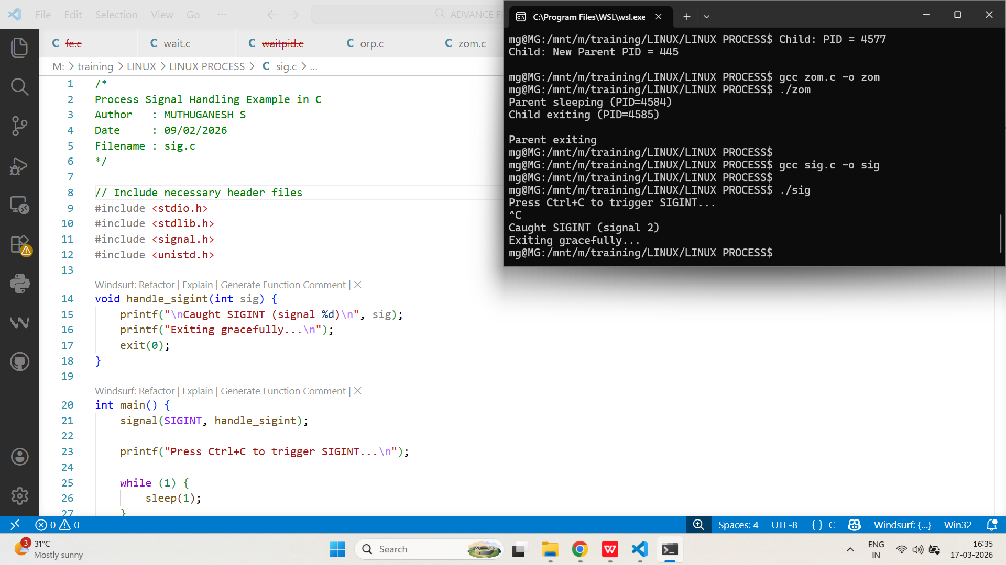
- Implement a program that sends SIGUSR1 to another process and handles it with a custom signal handler.
PROGRAM:
/*
Program to send a signal to another process using kill() system call
Author: MUTHUGANESH S
Date : 09/03/2026
Filename : sig_s.c
*/

#include <stdio.h>
#include <signal.h>
#include <unistd.h>

int main() {
pid_t pid;

printf("Enter receiver PID: ");
scanf("%d", &pid);

if (kill(pid, SIGUSR1) == 0) {
printf("SIGUSR1 sent successfully\n");
} else {
perror("kill failed");
}

return 0;
}
/*
Program to send a signal to another and handle it
Author: MUTHUGANESH S
Date : 09/03/2026
Filename : sig_r.c
*/

// Include necessary header files
#include <stdio.h>
#include <signal.h>
#include <unistd.h>

void handle_sigusr1(int sig) {
printf("Received SIGUSR1 (signal %d)\n", sig);
}

int main() {
signal(SIGUSR1, handle_sigusr1);

printf("Receiver PID: %d\n", getpid());
printf("Waiting for SIGUSR1...\n");

while (1) {
pause(); // wait for signal
}

return 0;
}

OUTPUT:
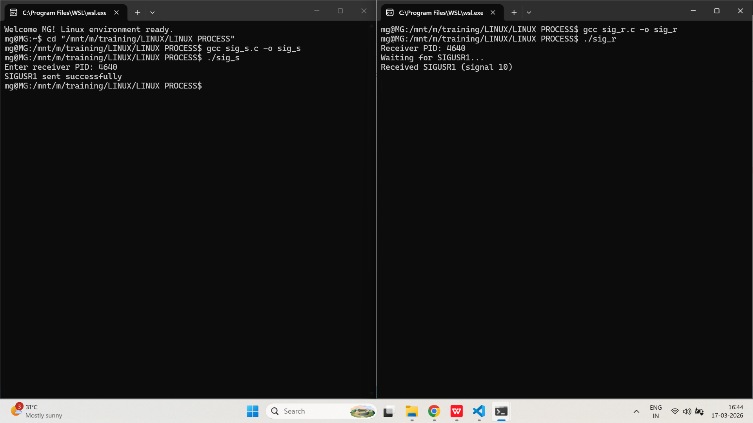

Signal Ignore, Signal Default
- Write a C program that ignores SIGINT and demonstrates that pressing Ctrl+C does not terminate the process.
PROGRAM:
/*
Program to ignore SIGINT signalprocess
Author : MUTHUGANESH S
Date : 10/03/2026
Filename : sig_i.c
*/

// Include necessary header files
#include <stdio.h>
#include <signal.h>
#include <unistd.h>
int main() {
// Ignore SIGINT
signal(SIGINT, SIG_IGN);
printf("SIGINT is ignored. Press Ctrl+C...\n");
while (1) {
printf("Running...\n");
sleep(2);
}
return 0;
}
OUTPUT:
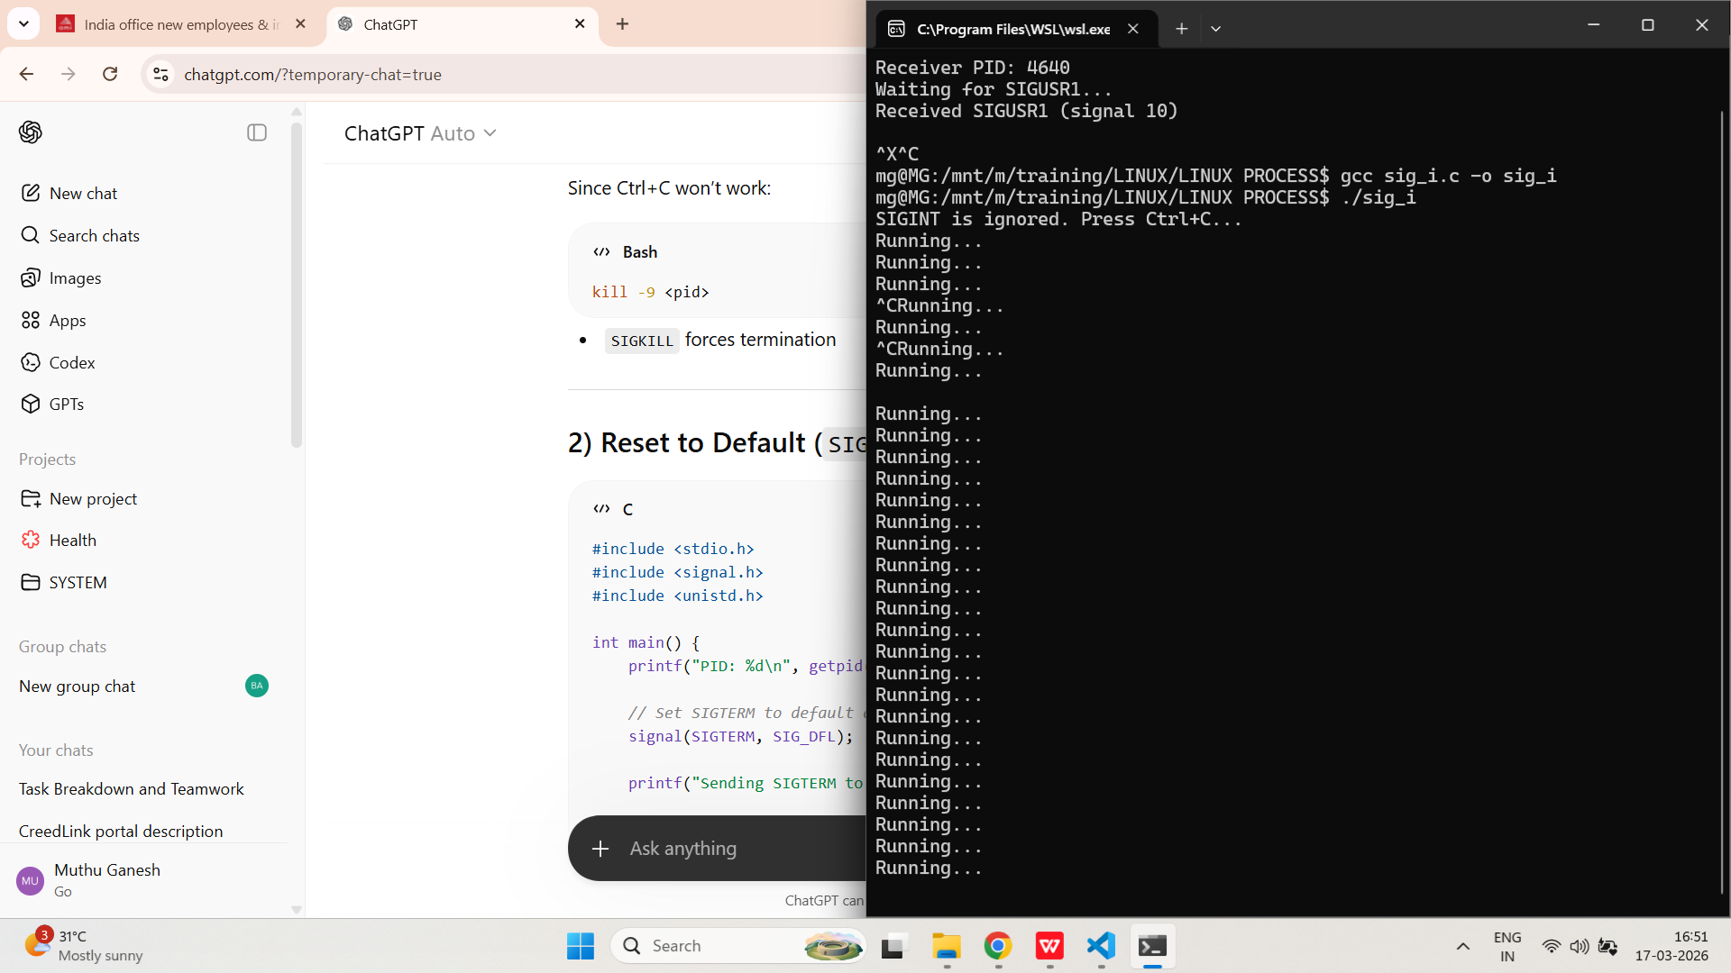
- Implement a program that sets the signal handler for SIGTERM to default, then sends SIGTERM to itself and observes the result.
PROGRAM:
/*
Program to set default action for SIGTERM signal
Author : MUTHUGANESH S
Date : 10/03/2026
Filename : sig_d.c
*/

#include <stdio.h>
#include <signal.h>
#include <unistd.h>

int main() {
printf("PID: %d\n", getpid());

// Set SIGTERM to default action
signal(SIGTERM, SIG_DFL);

printf("Sending SIGTERM to self...\n");

sleep(2); // delay for observation

kill(getpid(), SIGTERM);

// This line will NOT execute if default action occurs
printf("This line should not be printed\n");

return 0;
}
OUTPUT:
